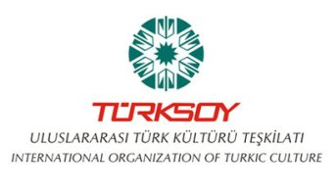
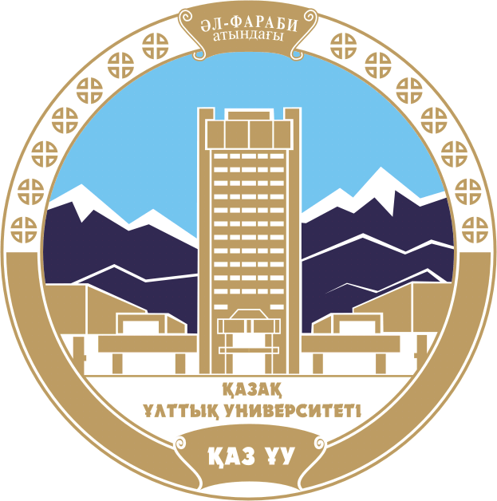
Call for Papers

INTERNATIONAL ORGANIZATION OF TURKIC CULTURE TURKSOY
AL-FARABI KAZAKH NATIONAL UNIVERSITY FACULTY OF ORIENTAL STUDIES
TURKSOY DEPARTMENT

DEAR COLLEAGES!

APRIL 12, 2016

In the Scientific Library of Al-Farabi Kazakh National University will be held

INTERNATIONAL SCIENTIFIC-THEORETICAL CONFERENCE
CONTRIBUTION OF YUSUF BALASaGUNI CREATION TO TURKIC WORLD CULTURE,
Devoted to 1000-years of great thinker, scientist and poet Yusuf Balasaguni

Yusuf Balasaguni is on a par with the likes of thinkers as Abu Nasr al-Farabi, Khoja Ahmed Yassaui, Mahmud Kashgar. He is a great thinker and poet of Qarakhanid era. He lived and worked in the XI century in the capital city of Karakhanids in Balasagun. Even during his lifetime he was awarded the title "Has Hajib". His main work "Kudatgu Bilig" ( "Beneficial Knowledge"), written in the Turkic language is considered a masterpiece of medieval era.
In connection with the 1000 anniversary of the great thinker 2016 was declared by the International Organization of Turkic Culture TURKSOY as a year of Yusuf Balasaguni.
Proposed conference topics reflect different aspects of the life and work of the great thinker, poet and scientist Yusuf Balasaguni.
The conference invited domestic and foreign researchers, PhD students, graduates, students, who study Yusuf Balasaguni`s creation.
Conference languages are Kazakh, Russian, English and Turkish.

FOLLOWING TOPICS ARE PRPPOSED FOR DISCUSSION:

- Yusuf Balasaguni as Person, His Works;
- The Role of Yusuf Balasaguni in Development of Medieval Turkic Languages;
- Importance of Yusuf Balasaguni`s Poetry in the World Literature;
- Philosophy Conceptions of Yusuf Balasaguni;
- The Meaning of Yusuf Balasaguni`s Creation in Studying Turkic Peoples History;
- Yusuf Balasaguni`s Contribution to World Scientific Development;
- «Kudatgu Bilig» («Beneficial Knowledge») as a Writing Monument of Qarakhanid Era.

Please, fulfill application form till March 15, 2016 and submit presentation paper to organizational committee till March 31, 2016 for publication.
Please, e-mail your papers to: gabdullin_k@mail.ru, turki_alemi@mail.ru, naza_yes@mail.ru (volume 5-10 pages). Materials should be sent in Word format. Please, name files with your family names in Latin: for articles Bilge.dok, Times New Roman, size - 14, other printing of Kazakh, Russian and English texts would be not accepted. Article less than 5 pages is not accepted.
Conference presentations are accepted in thesis up to 2 pages.

HOST OF CONFERENCE:
International organization of Turkic culture “TURKSOY” and Department of TURKSOY (School of Oriental Studies, Al-Farabi Kazakh National University).

PAPER FORMATTING:
1. Place title in the centre (capital letters, half-dark type, 14).
2. Below author’s family name and initials (small letters, 12);
3. Under the name – representing organization, city, university (small letters, 12);
4. Below – e-mail (in italics, 10);
5. Article summary 5-7 sentences in language article written, Russian, Kazakh or English (11);
6. Key words in language article written, Russian, Kazakh or English (not more than 5 words, small letters, in italics, 10);
7. Margins: upper and bottom, left and right – 20 мм, book type;
8. Line spacing – single;
9. Reference pattern:
1. Urlov F.N., Urlova Е.С. History of India. ХХ c. – M.: Institute of oriental Studies, RAC, 2010. − 920 p.
Citation inside the text should be like: [1, 23], where 1 – source title, 23 – page; [1; 10], where the number with semicolon indicates sources referred.
Application must be fulfilled in accordance with form.
Contacts: kafedra.kaznu@mail.ru
Phone: 8(727) 243 89 26

Registration fee is 3 000 tenge – for Kazakhstan peoples, 5000 – for foreigners should be paid till March 31, 2016 along with paper. Publication – upon the end of conference. Mailing is not included into registration fee.
Please pay special attention for mentioned in this letter conditions.
Conference venue: 050040, Almaty city, Al-Farabi avenue 71, Al-Farabi KazNU, Scientific Library.
Check in April 12, 2016 г. in 9.00 am
Executives: Gabdullin Kenzhebek gabdullin_k@mail.ru, Kortabayeva Gulzhamal turki_alemi@mail.ru, Yeshmetova Balzhan zhan_bal@mail.ru, Yesimbekova Nazira naza_yes@mail.ru, of. 431 Phone: 8(727) 243 89 26

The Committee keeps the right to decline materials, which doesn’t match conference subject or formatting requirements.
Materials would be published in author’s reduction; authors bear responsibility on authenticity of presented information.

Application form
of the international research conference participant
“CONTRIBUTION OF YUSUF BALASUGUNI CREATION TO TURKIC WORLD CULTURE”

Last name ____________________________________________________
First name ________________________________________________________
Middle name ____________________________________________________

Country _____________________________________________________
City ______________________________________________________
Address ______________________________________________________
Phone __________________________________________________
E-mail ___________________________________________

Organization ________________________________________________
Position __________________________________________________

Academic degree______________________________________________
Academic rank _______________________________________________

Subject of report _______________________________________________

